Uni-Pool: Verified Student Carpooling App

Executive Summary
Uni-Pool is a new mobile app designed specifically for university students to make commuting easier, safer, and cheaper. In a world where public transport is overcrowded and ride-sharing services like Bykea , Indrive and Yango are pricey for daily use, Uni-Pool connects verified students from the same university for carpooling. By requiring a .edu email or student ID for signup, it ensures everyone is legit, building trust and community. This app addresses a real unmet need in student life, potentially saving users money while reducing traffic and emissions. We're launching this as an entirely new business for our Innovation and Entrepreneurship course project, focusing on solving a everyday problem with tech.

Problem Statement
University students often struggle with getting to campus reliably and affordably. Public buses and trains are packed during peak hours, leading to delays and discomfort. Services like Bykea , Indrive can cost a fortune if used daily – think 500-1000 PKR per trip in big cities like Lahore or Karachi. Informal WhatsApp groups for carpooling exist, but they're messy: no verification means safety risks (especially for female students), mismatched schedules, and unreliable rides. This results in wasted time, higher stress, and even skipped classes. Plus, with rising fuel costs and environmental concerns, solo driving isn't sustainable. Our research shows that over 70% of students in Pakistan face commuting issues, based on quick surveys and online forums.

Solution Description
Uni-Pool is a user-friendly app that matches students based on their location, campus, and schedule. Here's how it works:
- Signup and Verification: Users log in with their university email (.edu) or upload a student ID for quick approval. This keeps it exclusive to real students.
- Matching System: Enter your home area, campus destination, and preferred times. The app uses GPS and algorithms to suggest matches, like grouping 3-4 students from the same neighbourhood.
- Features:
  - Real-time ride requests and confirmations.
  - In-app chat for coordination.
  - Rating system to build trust (e.g., rate drivers/passengers after rides).
  - Cost-sharing calculator to split fuel fairly.
  - Safety tools: Share live location with emergency contacts, verify vehicle details.
Tech Stack: Tech Stack (UI-Focused Prototype): Since this is a course project, we're focusing on building a high-fidelity UI prototype using Figma for interactive wireframes and mock ups. This will include all key screens (onboarding, verification, home dashboard, matching, chat, profile) to demonstrate the user experience. We can later suggest Flutter for actual development if scaled.
To give you an idea of what the app could look like:
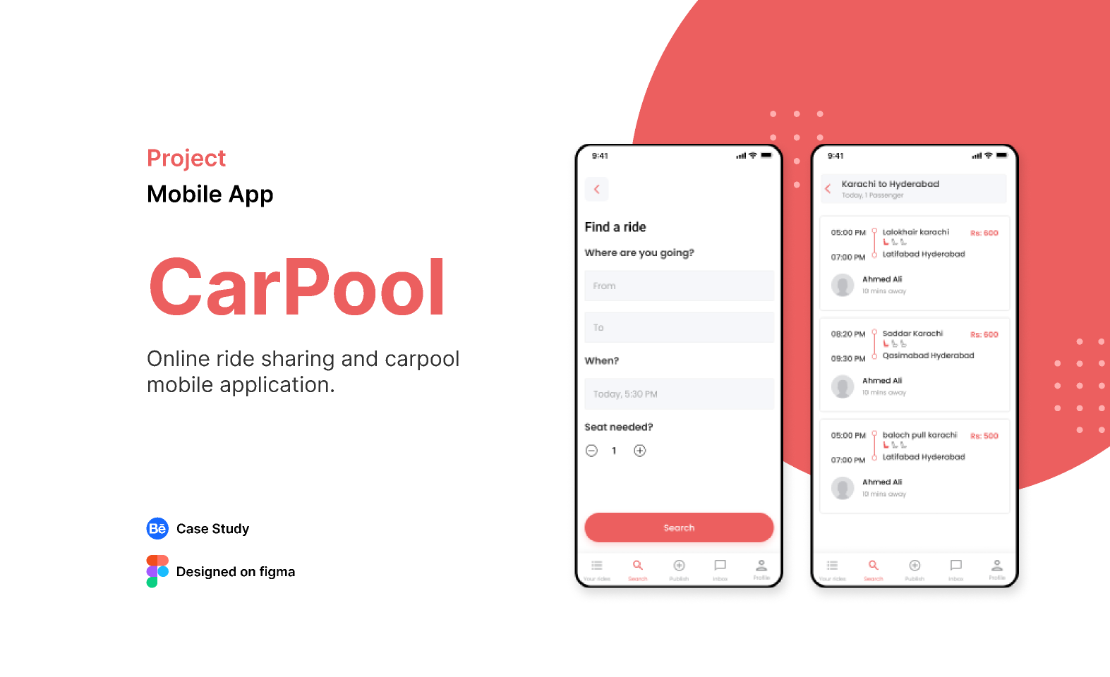
These mockups show a clean interface for matching and chatting – simple for students on the go.

Market Analysis
The student commuting market is huge, especially in developing countries like Pakistan with growing university enrollments (over 2 million students nationwide). Globally, the carpooling industry is booming – valued at $8 billion in 2023 and expected to hit $20 billion by 2030, driven by apps like BlaBlaCar. In Pakistan, with traffic congestion in cities like Islamabad and high fuel prices, there's a gap for student-focused solutions. Trends like sustainability (reducing carbon footprints) and gig economy sharing make this timely. Potential market size: Targeting just one university like LUMS , UMT or NUST could start with 10,000 users, expanding to multiple campuses.

Target Audience
- Primary: University students aged 18-25, living off-campus in urban areas.
- Secondary: Recent grads or faculty who commute similarly.
- Demographics: Tech-savvy, budget-conscious, environmentally aware. Focus on co-ed universities where safety is a big concern.
- Pain Points: Cost, time, safety – Uni-Pool hits all.

Competitive Landscape
- Direct Competitors: In Pakistan, apps like Carpoolyn (billed as the first carpooling app in the country), MAS Carpool, Humsafar RideShare, and Easy Lift PK offer general carpooling services, connecting drivers and passengers for inter-city or daily commutes. However, none are exclusively tailored for verified university students, often serving a broader audience without campus-specific features. PinkGo provides women-only rides and carpooling, targeting students at universities like COMSATS and LUMS, but it's gender-specific and not open to all students.
- Indirect: Established ride-hailing platforms like inDrive, and Bykea offer pooling or shared ride options, but they are generally more expensive for daily use and lack student verification or community focus. Informal methods like WhatsApp or Facebook groups and platforms like Carpool World remain common for ad-hoc arrangements, but they suffer from disorganization, no verification, and safety concerns.
- Our Edge: Uni-Pool differentiates through its strict student-only verification (.edu email or ID), hyper-local matching for campus commutes, and integrated safety tools like live location sharing. By focusing exclusively on universities and potential partnerships with campuses (e.g., integrations with student portals), we create a trusted, niche community that's safer and more efficient than general apps.

Business Model
- Revenue Streams:
  - Freemium: Basic matching free; premium features like priority matching or ad-free for a small fee (e.g., 100 PKR/month).
  - Partnerships: Ads from campus brands (e.g., food delivery, study apps) or sponsorships from universities for eco-initiatives.
  - Commission: Small cut from optional in-app payments for fuel sharing.
- Cost Structure: Low Startup – app development (~50,000 PKR via freelancers), marketing via social media. Scale with user growth.
- Break-Even: Aim for 5,000 active users in first year to cover costs.

Marketing and Growth Strategy
- Launch Plan: Start with one university (e.g., your own), promote via campus events, flyers, and social media groups.
- Digital Marketing: Instagram/TikTok ads targeting students, influencer partnerships with uni vloggers.
- Growth Hacks: Referral bonuses (e.g., free premium for inviting friends), integrations with university portals.
- Metrics: Track downloads, active users, rides completed – aim for 20% monthly growth.

Implementation Plan
- Timeline:
  - Month 1: Research and prototype (wireframes, basic app).
  - Month 2: Development and testing with beta users.
  - Month 3: Launch and feedback loop.
- Team Roles: If group project – one for tech, one for marketing, one for research.
- Budget: Under 100,000 PKR – use free tools like Canva for designs, GitHub for code.

Risks and Challenges
- Safety Issues: Mitigate with strict verification and reporting features.
- Adoption: Overcome by starting small and building word-of-mouth.
- Legal: Ensure compliance with data privacy (e.g., GDPR-like rules) and transport regs.
- Tech Glitches: Test thoroughly; have backups.

Conclusion
Uni-Pool isn't just an app – it's a game-changer for student life, making commutes fun, safe, and green. By solving a real problem with innovation, it has strong potential for success and scalability. We're excited to pitch this tomorrow and get feedback. Let's make commuting suck less! If we need to tweak based on the project outline, we're flexible.

